**Lab#2: Logic Gates**

The objective of this lab is to verifythe Truth Table for OR, NAND, NOT and NOR gates. It also shows you how to create multiple circuits in on .circ file.

1. Open the .circ file you created in Lab 1
2. From the Menu, select Project, Add Circuit…
3. Name the circuit Lab 2.
4. Note that you will have a second circuit in the file. The magnifying glass will now be on the second circuit and that circuit will be displayed on the canvas. You can switch between circuits by double clicking on the circuit name.

**OR gate Operation**

1. Design figure 1 on the Lab 2 circuit
2. Label each input and output according to Figure 1 by using the options in the tool bar

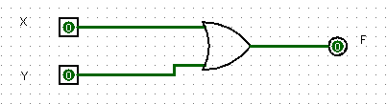

Figure 1: 2-input OR gate

1. Use the Poker Tool to change the values of the Input Pins.
2. Complete the Truth Table for 2-Input OR gate:

|  |  |  |
| --- | --- | --- |
| X | Y | F |
| 0 | 0 | 0 |
| 0 | 1 | 1 |
| 1 | 0 | 1 |
| 1 | 1 | 1 |

B**. NOT gate or Inverter**:

1. Design figure 2 on the Lab 2 circuit (below the OR) 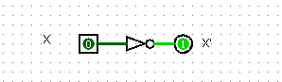
2. Complete the Truth Table of NOT gate:

|  |  |
| --- | --- |
| X | X’ |
| 0 | 1 |
| 1 | 0 |

C**. Two Input NAND gate**:

1. Design figure 3 on the Lab 2 circuit (below the NOT)

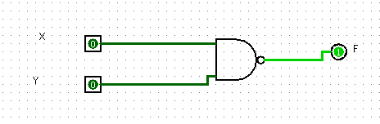

1. Verify truth table of NAND gate by competing its truth table

|  |  |  |
| --- | --- | --- |
| X | Y | F |
| 0 | 0 | 1 |
| 0 | 1 | 1 |
| 1 | 0 | 1 |
| 1 | 1 | 0 |

C. **Two Input NOR gate**:

1. Design figure 3 on the Lab 2 circuit (below the NAND) 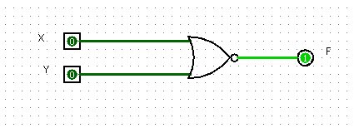
2. Verify truth table of NOR gate and Completing its Truth table

|  |  |  |
| --- | --- | --- |
| X | Y | F |
| 0 | 0 | 1 |
| 0 | 1 | 0 |
| 1 | 0 | 0 |
| 1 | 1 | 0 |